Tab 4
ITA0601
MACHINE LEARNING

EXP 14
Implement House price Prediction using appropriate machine learning algorithm

Procedure
1. Import the Linear Regression model.
2. Create the dataset and target values.
3. Train the model using the training data.
4. Predict the house price for a new input.
5. Display the predicted result.

Dataset 1: House Features and Pricing
Below is the data showing house size, bedroom count, house age, and corresponding prices:
House Size (sq. ft) | Bedrooms | House Age (Years) | House Price (₹ Lakhs)
800 | 2 | 15 | 35
1000 | 2 | 12 | 42
1200 | 3 | 10 | 52
1400 | 3 | 8 | 63
1600 | 4 | 6 | 75
1800 | 4 | 5 | 88
2000 | 5 | 4 | 102
2200 | 5 | 3 | 118
2400 | 6 | 2 | 135
2600 | 6 | 1 | 150

Target Variable: House Price (₹ Lakhs)

New Sample for Prediction
House Size (sq. ft) | Bedrooms | House Age (Years)
1700 | 4 | 5

PROGRAM

import numpy as np

X = np.array([
[800, 2, 15],
[1000, 2, 12],
[1200, 3, 10],
[1400, 3, 8],
[1600, 4, 6],
[1800, 4, 5],
[2000, 5, 4],
[2200, 5, 3],
[2400, 6, 2],
[2600, 6, 1]
])

y = np.array([35, 42, 52, 63, 75, 88, 102, 118, 135, 150])

X = np.column_stack((np.ones(len(X)), X))

model = np.linalg.inv(X.T @ X) @ X.T @ y

new_sample = np.array([1, 1700, 4, 5])

prediction = new_sample @ model

print("Predicted House Price:", round(prediction, 2), "Lakhs")

OUTPUT

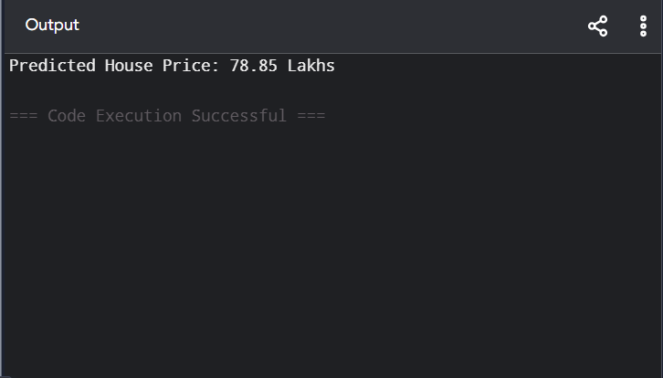

Dataset 2: House Location and Parking Features
The data below illustrates house area, urban proximity, and parking capacity relative to pricing:
Area (sq. ft) | Distance (km) | Parking Spaces | House Price (₹ Lakhs)
900 | 20 | 1 | 40
1100 | 18 | 1 | 48
1300 | 16 | 2 | 60
1500 | 14 | 2 | 74
1700 | 12 | 2 | 88
1900 | 10 | 3 | 104
2100 | 8 | 3 | 122
2300 | 6 | 4 | 142
2500 | 5 | 4 | 165
2700 | 3 | 5 | 190

Target Variable: House Price (₹ Lakhs)

New Sample for Prediction
Area (sq. ft) | Distance (km) | Parking Spaces
1800 | 11 | 3

PROGRAM

import numpy as np

X = np.array([
[900, 20, 1],
[1100, 18, 1],
[1300, 16, 2],
[1500, 14, 2],
[1700, 12, 2],
[1900, 10, 3],
[2100, 8, 3],
[2300, 6, 4],
[2500, 5, 4],
[2700, 3, 5]
])

y = np.array([40, 48, 60, 74, 88, 104, 122, 142, 165, 190])

X = np.column_stack((np.ones(len(X)), X))

model = np.linalg.inv(X.T @ X) @ X.T @ y

new_sample = np.array([1, 1800, 11, 3])

prediction = new_sample @ model

print("Predicted House Price:", round(prediction, 2), "Lakhs")

OUTPUT

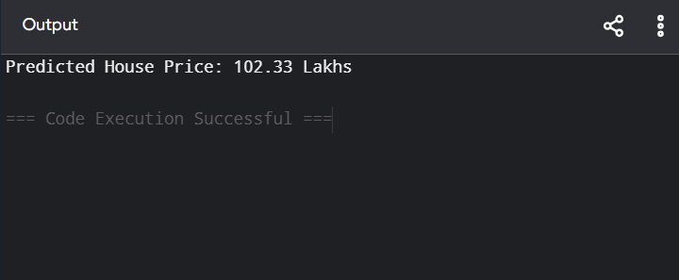

Dataset 3: House Area, Floors, and Garden Size
The following table provides details regarding house area, floor count, and garden square footage in relation to market price:
House Area (sq. ft) | Floors | Garden Area (sq. ft) | House Price (₹ Lakhs)
1000 | 1 | 100 | 45
1200 | 1 | 120 | 55
1400 | 2 | 150 | 68
1600 | 2 | 180 | 82
1800 | 2 | 200 | 96
2000 | 3 | 240 | 112
2200 | 3 | 280 | 130
2400 | 3 | 320 | 150
2600 | 4 | 350 | 172
2800 | 4 | 400 | 196

Target Variable: House Price (₹ Lakhs)

New Sample for Prediction
House Area (sq. ft) | Floors | Garden Area (sq. ft)
2100 | 3 | 250

PROGRAM

import numpy as np

X = np.array([
[1000, 1, 100],
[1200, 1, 120],
[1400, 2, 150],
[1600, 2, 180],
[1800, 2, 200],
[2000, 3, 240],
[2200, 3, 280],
[2400, 3, 320],
[2600, 4, 350],
[2800, 4, 400]
])

y = np.array([45, 55, 68, 82, 96, 112, 130, 150, 172, 196])

X = np.column_stack((np.ones(len(X)), X))

model = np.linalg.inv(X.T @ X) @ X.T @ y

new_sample = np.array([1, 2100, 3, 250])

prediction = new_sample @ model

print("Predicted House Price:", round(prediction, 2), "Lakhs")

OUTPUT

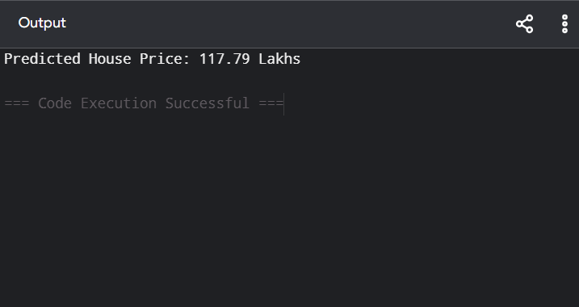

Dataset 4: Apartment Price Prediction
The following figures detail apartment dimensions, level positioning, and structure age in relation to valuation:
Apartment Size (sq. ft) | Floor Number | Building Age (Years) | House Price (₹ Lakhs)
700 | 1 | 15 | 30
850 | 2 | 12 | 38
1000 | 3 | 10 | 48
1150 | 4 | 8 | 60
1300 | 5 | 7 | 72
1450 | 6 | 5 | 86
1600 | 7 | 4 | 100
1750 | 8 | 3 | 116
1900 | 9 | 2 | 134
2050 | 10 | 1 | 154

Target Variable: House Price (₹ Lakhs)

New Sample for Prediction
Apartment Size (sq. ft) | Floor Number | Building Age (Years)
1500 | 6 | 4

PROGRAM
import numpy as np

X = np.array([
[700, 1, 15],
[850, 2, 12],
[1000, 3, 10],
[1150, 4, 8],
[1300, 5, 7],
[1450, 6, 5],
[1600, 7, 4],
[1750, 8, 3],
[1900, 9, 2],
[2050, 10, 1]
])

y = np.array([30, 38, 48, 60, 72, 86, 100, 116, 134, 154])

X = np.column_stack((np.ones(len(X)), X))

model = np.linalg.inv(X.T @ X) @ X.T @ y

new_sample = np.array([1, 1500, 6, 4])

prediction = new_sample @ model

print("Predicted House Price:", round(prediction, 2), "Lakhs")

OUTPUT

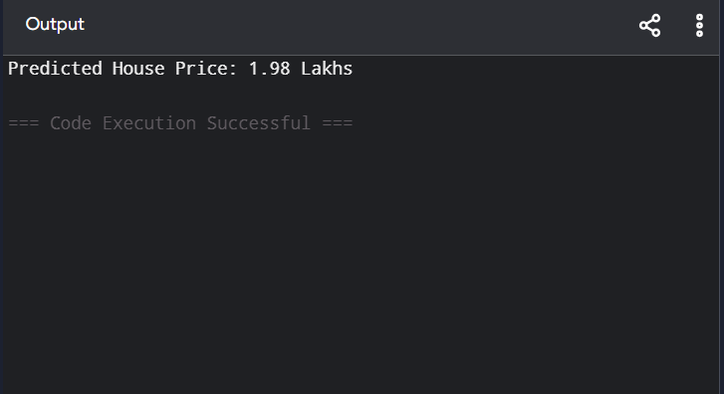

Dataset 5: Independent House Price Prediction
The data below illustrates plot dimensions, constructed space, and restroom count relative to valuation:
Plot Area (sq. ft) | Built-up Area (sq. ft) | Bathrooms | House Price (₹ Lakhs)
1200 | 900 | 2 | 48
1400 | 1100 | 2 | 60
1600 | 1300 | 3 | 74
1800 | 1500 | 3 | 90
2000 | 1700 | 4 | 108
2200 | 1900 | 4 | 128
2400 | 2100 | 5 | 150
2600 | 2300 | 5 | 174
2800 | 2500 | 6 | 200
3000 | 2700 | 6 | 228

Target Variable: House Price (₹ Lakhs)

New Sample for Prediction
Plot Area (sq. ft) | Built-up Area (sq. ft) | Bathrooms
2300 | 2000 | 4

PROGRAM
import numpy as np

X = np.array([
[1200, 900, 2],
[1400, 1100, 2],
[1600, 1300, 3],
[1800, 1500, 3],
[2000, 1700, 4],
[2200, 1900, 4],
[2400, 2100, 5],
[2600, 2300, 5],
[2800, 2500, 6],
[3000, 2700, 6]
])

y = np.array([48, 60, 74, 90, 108, 128, 150, 174, 200, 228])

X = np.column_stack((np.ones(len(X)), X))

model = np.linalg.inv(X.T @ X) @ X.T @ y

new_sample = np.array([1, 2300, 2000, 4])

prediction = new_sample @ model

print("Predicted House Price:", round(prediction, 2), "Lakhs")

OUTPUT

